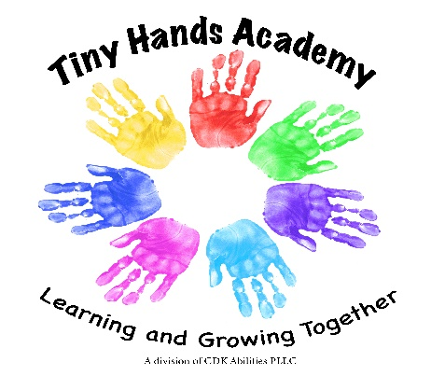
melissa.tinyhandsacademy@gmail.com
518-307-3494 (Melissa)
518-409-8124 (building phone)
Welcome!
We are so excited to have you joining our play group!
Here is a list of things that your child will need for school:

- Backpack or bag with their name labeled on it please.
- Extra clothing including socks, pants or shorts and long/short sleeve shirt. (Please place in Zip bag with name on it) Can be kept in their backpack or at school.
- Small Package of diapers.
- Box of tissues and package of wipes to share with the class through the year.
- Prepared meal/snack daily with a drink in a cup with their name on it please. Please have food ready to eat as they get very excited to eat! We will provide disposable spoons, forks and plates as needed. We aways have extra snacks to share. You are welcome to send in a birthday snack to celebrate their special day!

- Please send your child in clothes they can run, play and get messy in. We love paint, glue, glitter, dirt and water! They will get dirty! Please make sure your child can run and climb safely in their clothing and shoes.

We are so excited to have your child join our class!!

