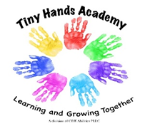
100 Maple Street, Glens Falls, NY 12801
(518) 409-8124

Information About Your Child

The first day of preschool is an exciting time for children and families. It can also be a little scary, so in
order for us to get to know your child a little better, we ask that you complete this information sheet. If
your child is feeling sad or afraid the first few days, this information may help us connect in a way we
might not otherwise be able to.

Child’s Full Name _____________________ What they prefer to be called ________________
Please list siblings and ages ______________________________________________________________
Names of other people who live in the home (grandparents, cousins, etc.)_________________________
_____________________________________________________________________________________
Any Pets? ____________________________________________________________________________
Favorites:
Food ______________________________________________________
Toys _______________________________________________________
TV or Movie Characters ________________________________________
Other ______________________________________________________

Does your child have any strong fears? _____________________________________________________
(Thunderstorms, the dark, animals, etc.)

Please list any allergies your child has and what reaction could be expected: _____________________________________________________________________________________
_____________________________________________________________________________________

Is there anything else you would like us to know about your child?
_____________________________________________________________________________________
_____________________________________________________________________________________
____________________________________________________________________________________

