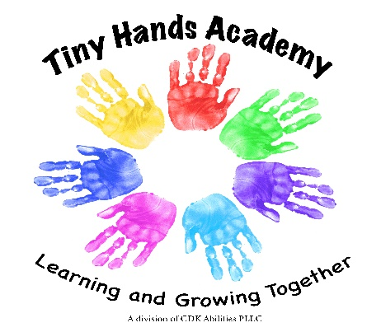
Preschool/PreK Classroom
Pam Conine (518) 415-0323 pam.tinyhandsacademy@gmail.com
Jessica French (518) 409-3170 jessica.tinyhandsacademy@gmail.com
Here is a list of things that your child will need for school:
- Backpack large enough for extra clothes and to take home their artwork
- Extra clothing including socks, pants/shorts, shirt, underwear.
- If your child is using pullups, please pack at least 2 each day and wipes.
- Please send your child in clothes they can run, play and get messy in. We love paint, glue, glitter, dirt and water! They will get dirty! *Please make sure your child’s clothing and shoes allow them to run and climb safely.
- We ask each family to donate a box of Kleenex and a box of zip lock baggies (sandwich, quart or gallon size) to be used in the classroom throughout the year.
- A few family photos including pets if available. We will use these throughout the year for different things but especially to help the children tell us about who is important to them!
The Preschool and PreK classroom will distribute a snack calendar monthly. When your child’s name appears on the calendar it is your turn to bring snack for the whole class on that day. The snack items we accept as well as any particular food to avoid due to an allergy are listed on the monthly calendar. We will serve bottled water which we will provide to the children each day. We use disposable cups and paper plates so there is no need for you to provide a cup or drink for your child. We will do our best to have your child assigned snack on or near their birthday, so you are welcome to bring a special birthday snack to celebrate.

